**Title : EECS 1022 Lab 03 - TAX CALCULATOR**

**Passport York username : kumarraj**

**Full Name : Rajkumar Balakrishnan Lakshmi (213141197)**

**Partner's Passport York - vhema**

**Partner's Name - Hemambika Vaidyanathan**

**Introduction:**

In this lab our objective was to create an app that calculates the Tax when a button is clicked. Android studio made it easier for us to build the app. The app consisted of one text box respectively for the user to input the annual income. It also consisted of a button, which on click calculated the Tax, Average Interest, Marginal Interest, CPP & Ei values from the users input  of annual income.

**Results:**

**Task 2:**We first tested the model using public static void main, and the output was perfectly correct as expected. Here is a screenshot showing the result:

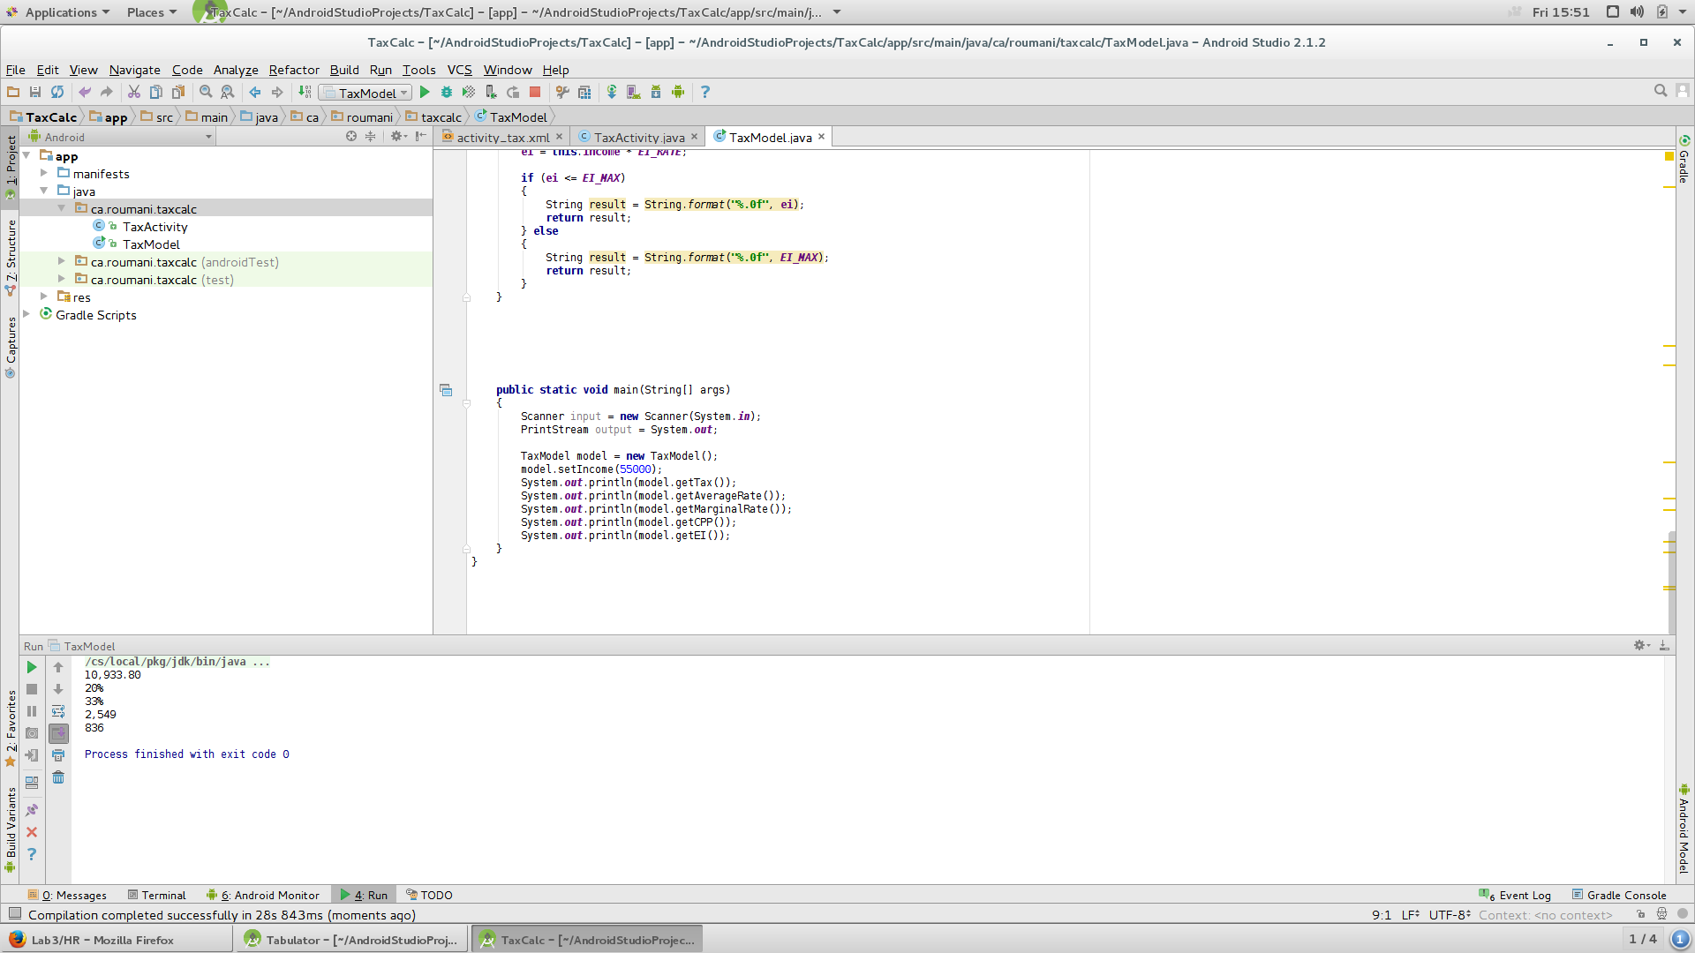

**Task 3:**Later we deployed it on the android tablet, by connecting it to the laptop.

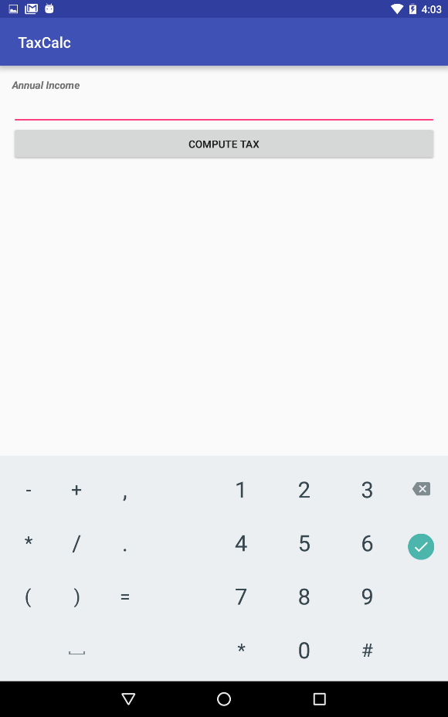

Screenshot after entering the Annual Income:

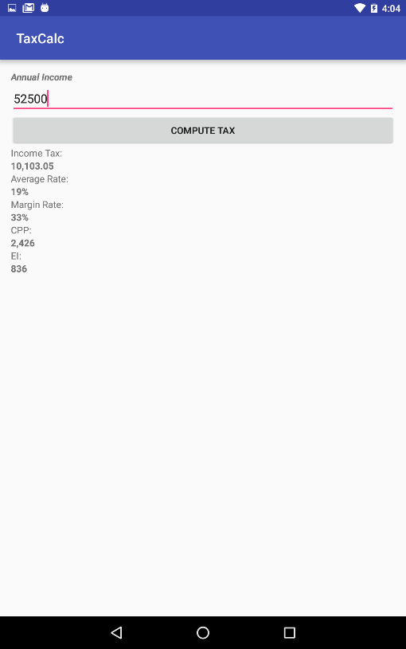

Herewith, I have attached the results and findings of this lab in the video format.

https://youtu.be/QW1FzmO1xn8

**Discussion:**

Although the android studio was new to me, the walk through video posted by the professor helped me a lot in completing the lab. In particular the design option for creating the view of the app saved more time rather than typing the code itself. Unlike other two labs we had to write the code for this lab from the scratch which was more interesting and required much more effort. But few code snippets provided in the lab documents helped a lot to understand the  requirement better.